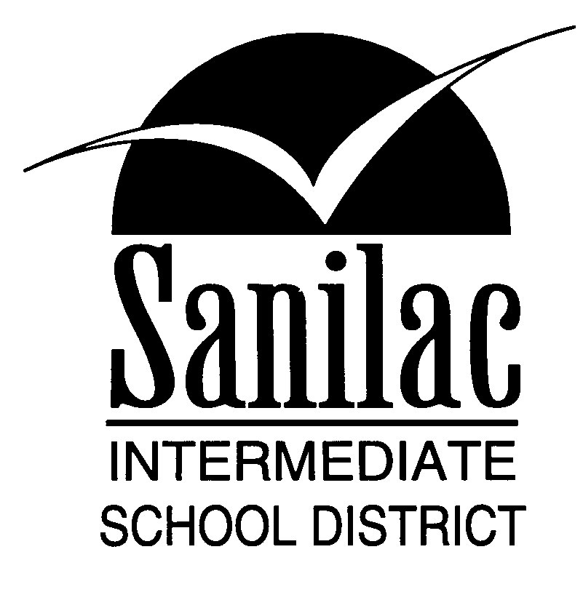
Special Education Services
46 North Jackson Street
Sandusky, Michigan 48471
810-648-2200
HEARING IMPAIRED CERTIFICATION FORM

Name of Student:__________________________________Birth Date:____________________

An otologic examination was completed on the above named individual on ________________.
Date
The results indicate a hearing impairment that is not based solely on behavior relating to environmental, cultural, or economic differences.

Health of Ears: ________________________________________________________________

Hearing Loss: _________________________________________________________________

Does the hearing loss adversely affect his/her educational performance? Yes_____ No _____
Comments: ____________________________________________________________________
____________________________________________________________________
____________________________________________________________________

Otologist: _____________________________________________________________________
Print Name
Otolaryngologist: _______________________________________________________________
Signature
Address: ______________________________________________________________________
______________________________________________________________________
______________________________________________________________________
Phone: ___________________________________ Fax: _____________________________

If your audiologist completed a hearing test,
please send a copy of the results (AIDED AND UNAIDED).

If you have any questions, please feel free to call at (810) 648-2200 Ext. 127.

PLEASE RETURN FORM TO:

Rebecca Lipka, MA, CCC-A
Educational Audiologist
Sanilac Intermediate School District
46 N Jackson Street
Sandusky, MI 48471
(810) 648-2200 Ext. 4120
Fax #: (810) 648-2275

